Healthplan Recommender for the 2020 ACA Marketplace

Problem.
The 2020 open enrollment period for the Affordable Care Act Marketplace runs from November 1 to Dec 15. It is daunting to decide which one to choose. For instance, there are 68 plans to select from for Miami, FL.

Proposal -
A healthplan recommender to assist in finding the right plan for you. The official federal marketplace has to be neutral (cannot infer A is better than B) as they are a host, not a recommender.

The advantage of my tool is it will make recommendations based on information not easily available (you have to go to the insurance agent’s separate website and download a brochure to see if dialysis is covered) on on the official marketplace.
A. Claim denial rates – How good is a plan if they never let you use it.
B. Percentage of individuals who signed up for the plan end of last year and coverage has been lost by Oct 1.
C. The marketplace has 9 categories listing (Acupuncture,Chiropractic,,Infertility,Mental Health -Inpatient, Mental-Health-Outpatient, Rehab (ie post surgical), Bariatric Services, Skilled Nursing Facility and Private Nurse) whether they are covered. Out of 1182666 identified benefits,
I have identified approximately 100 summary features that I believe someone would use to decide on coverage. I’m at 116 right now – still deciding whether to merge things like ‘eyeglasses-adults’ vs ‘eyeglasses-children’ and ‘Abortion’ vs’Abortion prohibited from using public funds’ . There were also 62364 exclusions that have been reduced down to 33 exclusion features. There are less exclusions because its easier to knock things out. Three different people will be interested in ‘cochlear implants’, ‘hearing aids’, and ‘audiology rehab’ as a benefit while the ‘No Auditory Services’ knocks out all those plans up front.

Method to get recommendation.

A. Fill out Flask form with the following info.

i. Demographics – Age and tobacco status for each insurance member.
ii. Zip Code
iii. Medical conditions important to the customer. Would like to use pulldown menus but not sure yet.
B. Plan descoping.

i. I have built a conversion table to changes zipcodes into areas of coverage. Geography is the biggest limiter of available plans. That table is used to find the plans for your area (68 for Miami).
ii. The available plans then take your vital conditions and runs them against the exclusions. This usually knocks out ~ 10% of plans. I will try to make the number of plans as small as possible for

C. Develop recommendations.
I plan on using an SVD factorization to build a model much like the movie recommender we did. However, each of my benefits will be the ‘movie’ features.
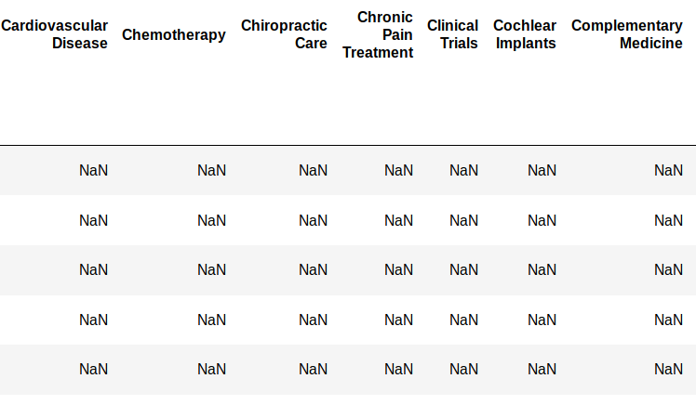
However, I will be pulling the top 5 M(insurance plans) to recommend instead of N (conditions). I have a huge advantage that once the model is built, it will be static – no new plans/plan changes since enrollment is only 45 days and good for the following year.

D. Provide the user with a list of the top five plans with their denial rates and churn rates.

Known issues and limitations.

1. I have started off working on modeling Florida to ensure I get a MVP for at least one state. Florida was chosen because first, they are by far the largest marketplace. It had 1,783,304 people enroll in 2019, over 300,000 more than 2nd place CA and 700,000 more than 3rd place TX. Second, Florida has the second widest average range of approval ratings after VA. Third, there are now only 9 insurance companies in the state. Lastly, Florida has a basic design for their plans – either cover the whole state or cover a county with no overlap for a carrier (If you have a state plan, you don’t have one just for a county).
2. At this point, I cannot include financial data. After working on my tables to calculate the rates, I discovered that the rates cross reference table available to the plans is flawed. I went to the marketplace to make sure my calculations would be the same and discovered that the keys did not match. For instance, plan 12379FL0010001 has the same benefits for 4 counties. However, there is 4 different rate structures (12379FL0010001-01 to 12379FL0010001-04) and the tables do not link the rate structure to the counties. The marketplace website shows 12379FL0010001 as the plan as well so it doesn’t help. I have sent a request to CMS for fill-in data but do not expect a reply in time.
3. If/when I expand, I can only do the 38 states on the national ACA marketplace. Any state (like CO) that has their own program is not in the data I have. I reached out to CO and they said I have to be a licensed broker to get that information during enrollment season. However, one of my CMS transparency datafiles provides the global (all plans for a company for a state) approval rates for the 6 CO companies so I could theoretically tell someone how their insurance company is rated at the capstone.
4. I am concerned about model size. Since the model(s) will be static once they are complete, I am considering doing one for each state instead of a national one. There are 1,182,666 total nationally. At at 100 sparse columns for features, I am concerned that even with a static model, it will stay take too much time for find the best 5 if all plans are included for each request.
5. There are 6 states like VA and NY that make assigning a plan to a zipcode difficult because they have plans at multiple geographic levels. For instance, the same insurer can have 4 plan groups for the same zipcode (1 statewide, 1 for NYC, 1 for Manhatten (county/borough), and 1 for Upper West Side), making it very difficult to determine which one you are actually eligible to use. In addition, there are several states (don’t have a count) that include SHOP plans in addition to individual. These are for companies <10 people and the plans are scheduled by the location of the business, not where you live.

Two most fun things found in EDA

1. Many states do an additive thing for their rates. The rate for a 4 year old is $42 per month, 12 year old sister is $57, 31 year old mom is $516, and 32 year dad is $ $518. You add them up and that’s what you pay. Companies can charge more if there is tobacco use but if a company decides to do tobacco, they have to provide a tobacco rate for all their plans. That means these additive plans have a tobacco rate for a 4 year old.

2. The formula for a healthcare tax credit is complicated but it seems to keep the rates fair. For instance, that family in #1 will probably get a $824.56 credit. Always take the tax credit when you sign up because at signup you can elect to lower your rate each month or get a refund in April 2021. You can’t change your mind. $825 per month is a lot of money to ‘loan’ out for 18 months.

